Radivoj V. Prodanović, Ph.D.
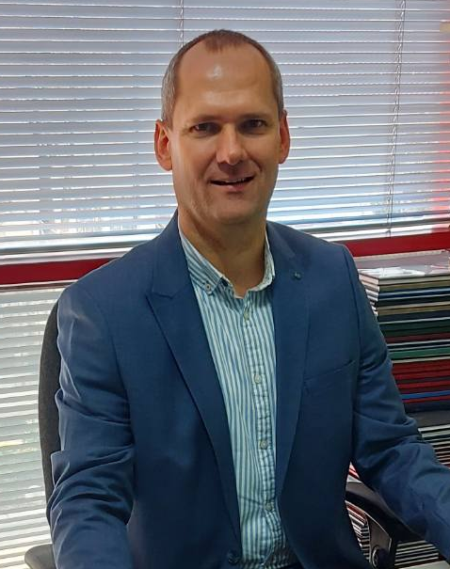
Radivoj Prodanović is Associate Professor of Economics in the field of agromanagement at the Faculty of Economics and Engineering Management, University Business Academy in Novi Sad. His main expertise concerns: agricultural economics, agricultural and rural policy, farm management, sustainable agricultural development and environmental protection. In recent years, he has focused on making decisions about problems on farms and sustainable production systems and technologies.
Professor in Jean Monnet Module " European sustainable values in Common agricultural policy", teaching courses: "Rural Policy of European Union" and "Serbian rural policy in context of EU integration", supported by the European Commission (EACEA).
He has also participated in many national projects, co-financed by the Provincial Secretariat for Higher Education and Scientific Research, Administration for Environmental Protection of the City of Novi Sad, and Ministry of Agriculture, Forestry and Water Economy.
He authored and co-authored more than 100 research articles in international and national scientific journals, proceedings of international and national scientific conferences in the field of economics of food production and processing, agromanagement, agromarketing, sustainable agricultural development and environmental protection.
He has experience in creating study programs and their professional evaluation. He is a member of editorial boards and a reviewer of several scientific journals. He is a reviewer of the National Entity for Accreditation and Quality Assurance in Higher Education (NEAQA) for the field of technical and technological sciences.
He has been a corresponding member of the IRASA Academy since 2019 for the Technical and Technological Scientific Area. He has been a member of the Balkan Scientific Association of Agricultural Economists since 2020.

